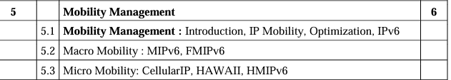

->Cellular IP

->HMIPV6

->IP Mobility

->FMIPV6

1. \*\*Cellular IP\*\*: Cellular IP is a technology that enables devices to communicate over cellular networks using standard IP-based protocols, just like devices do on the internet. It allows devices such as smartphones, tablets, and IoT devices to maintain connectivity and access internet services while on the move within the coverage area of cellular networks. Cellular IP ensures seamless communication by assigning unique IP addresses to devices and optimizing handover procedures as devices switch between different cellular towers.

2. \*\*HMIPv6 (Hierarchical Mobile IPv6)\*\*: HMIPv6 is an extension of Mobile IPv6 designed to improve the efficiency of handovers and reduce signaling overhead in mobile IPv6 networks. It introduces a hierarchical mobility management architecture, where mobile nodes are organized into mobility domains, each managed by a Mobility Anchor Point (MAP). HMIPv6 enhances scalability and reduces handover latency by localizing mobility management within specific network domains, ensuring seamless connectivity for mobile devices as they move between different access points.

3. \*\*IP Mobility\*\*: IP Mobility refers to the ability of a mobile device to maintain uninterrupted communication as it moves between different network access points or changes its point of attachment to the internet. It involves mechanisms and protocols such as Mobile IP, Proxy Mobile IPv6, and Hierarchical Mobile IPv6, which enable seamless handovers, address management, and routing optimizations in wireless networks. IP Mobility ensures that mobile devices can maintain connectivity and access network services regardless of their physical location or network attachment point.

4. \*\*FMIPv6 (Fast Mobile IPv6)\*\*: FMIPv6 is an enhancement of Mobile IPv6 designed to reduce handover latency and packet loss during mobility events in IPv6 networks. It introduces proactive handover mechanisms, where the mobile node initiates the handover process before moving to a new network, allowing it to maintain connectivity without interruption. FMIPv6 reduces handover latency by pre-configuring the new access point and enabling the mobile node to quickly switch to the new network, minimizing the impact on ongoing communication sessions.

IMPORTANT QUESTION:

Q. Describe use of cellular IP || Q. Describe use of cellular IP – 5M ||

Q. Explain use of cellular IP – 5M

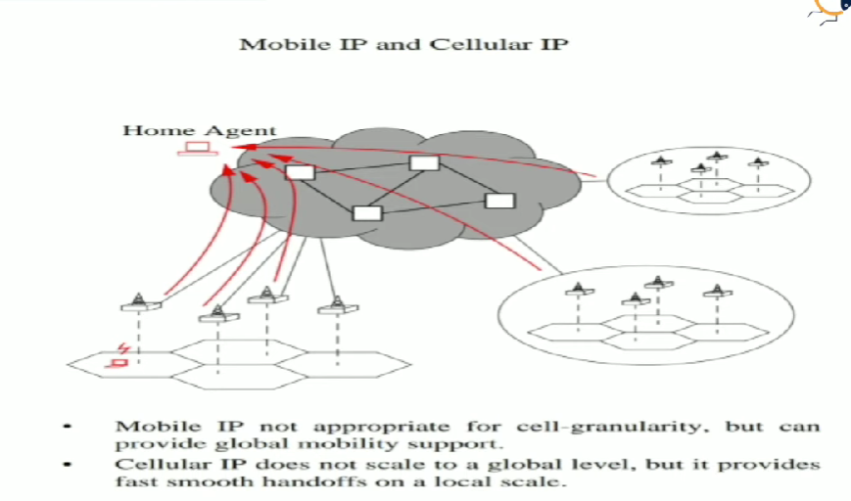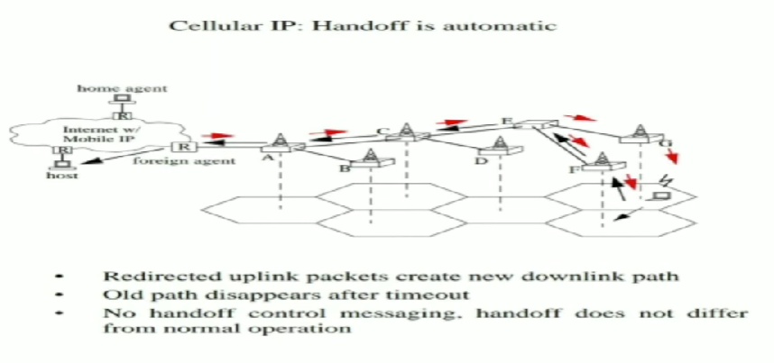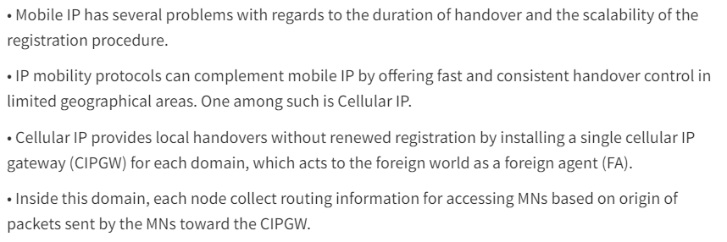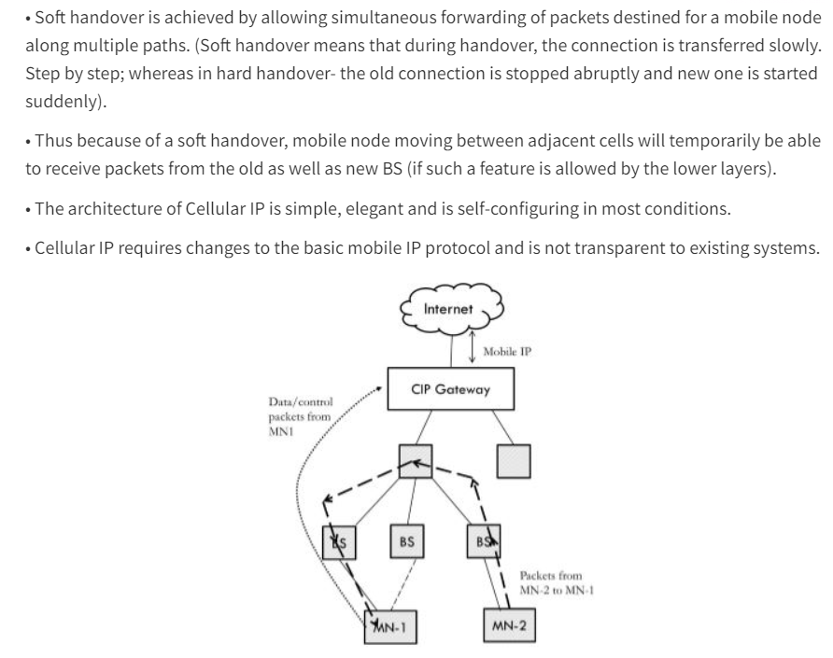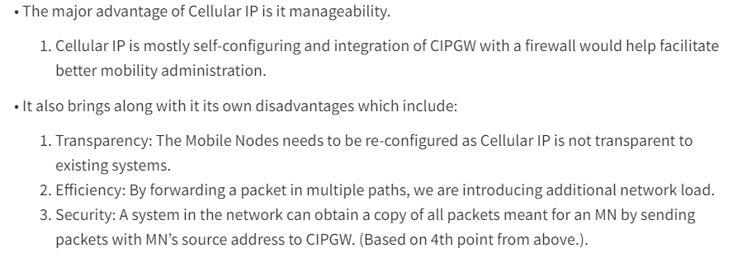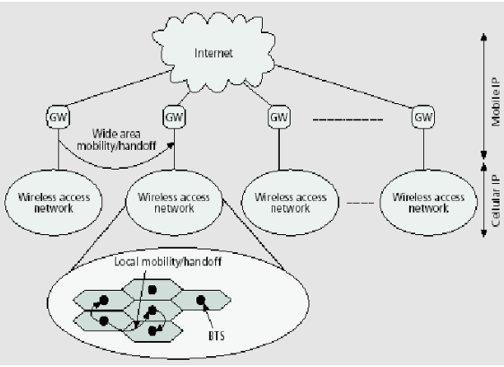

NEED FOR CELLULAR IP:

The need for Cellular IP arises from the increasing demand for mobile connectivity and the proliferation of devices requiring internet access while on the move. Here are some key reasons why Cellular IP became necessary:

1. \*\*Mobility\*\*: Traditional wired internet connections are not suitable for mobile devices like smartphones, tablets, and laptops that need to stay connected while on the move. Cellular IP allows these devices to maintain internet connectivity as they switch between different cellular towers and move across geographical areas covered by the cellular network.

2. \*\*Ubiquitous Coverage\*\*: Cellular networks provide broad coverage across urban, suburban, and rural areas, making them an ideal choice for delivering internet access to a wide range of locations. Cellular IP enables devices to connect to the internet virtually anywhere there is cellular coverage, allowing users to stay connected even in remote areas.

3. \*\*Flexibility\*\*: Cellular IP offers flexibility in terms of device mobility and network access. Users can access the internet from a variety of devices, including smartphones, tablets, laptops, and IoT devices, without being tied to a fixed location or wired connection. This flexibility is essential for today's mobile-centric lifestyles and the growing adoption of IoT technology.

4. \*\*Scalability\*\*: Cellular networks are designed to support a large number of simultaneous connections, making them well-suited for handling the increasing volume of mobile data traffic generated by smartphones, streaming services, IoT devices, and other connected devices. Cellular IP allows for the efficient routing of data packets across the network, ensuring reliable and scalable internet access for millions of users.

5. \*\*Emerging Technologies\*\*: The rise of new technologies and applications, such as augmented reality, virtual reality, autonomous vehicles, and smart cities, requires robust and high-speed internet connectivity on the go. Cellular IP enables these emerging technologies to leverage the capabilities of cellular networks and deliver immersive experiences and innovative services to users worldwide.

Overall, Cellular IP addresses the need for seamless, reliable, and high-speed internet connectivity on mobile devices, enabling users to stay connected, access online services, and interact with a wide range of digital applications wherever they go.

DESCRIBE USE:

Cellular IP (Internet Protocol) is a technology that enables devices to communicate over cellular networks using standard IP-based protocols, just like devices do on the internet. Here's how it works:

1. \*\*IP Address Assignment\*\*: Each device connected to the cellular network is assigned a unique IP address, just like on a regular internet connection. This IP address allows the device to send and receive data over the network.

2. \*\*Data Transmission\*\*: Once connected to the network, devices can send and receive data packets to and from other devices or servers on the internet. These packets are routed through the cellular network infrastructure to reach their destination.

3. \*\*Mobile Network Infrastructure\*\*: Cellular IP relies on the infrastructure of mobile network providers. This infrastructure includes cell towers, base stations, and other network elements that facilitate communication between devices and the broader internet.

4. \*\*Protocols and Standards\*\*: Cellular IP typically utilizes standard IP protocols such as TCP/IP (Transmission Control Protocol/Internet Protocol) for communication. These protocols ensure reliable and efficient data transmission over the cellular network.

5. \*\*Security\*\*: Cellular IP networks often incorporate encryption and other security measures to protect data transmitted over the network from unauthorized access or interception. This helps ensure the privacy and integrity of data exchanged between devices.

6. \*\*Applications\*\*: Cellular IP is used in various applications, including mobile internet access for smartphones, tablets, and laptops, as well as in IoT (Internet of Things) devices such as connected cars, industrial sensors, and smart home devices. It provides these devices with the ability to communicate over cellular networks and access internet services wherever cellular coverage is available.

Overall, cellular IP plays a crucial role in enabling mobile connectivity and facilitating communication between devices over cellular networks.

Q. What is micro mobility and its approaches || Q. What is micro mobility and its approaches? – 10M

In the context of mobile computing, micro-mobility refers to the ability of mobile devices to maintain connectivity and seamlessly roam between different access points within a localized area, such as a campus, building, or public hotspot. Micro-mobility is essential for ensuring uninterrupted communication and service continuity for mobile users as they move within a confined geographical area. Here's how Cellular IP, HAWAII, and HIMPv6 approaches contribute to micro-mobility in mobile computing:

1. \*\*Cellular IP\*\*: Cellular IP enables mobile devices to maintain connectivity and access network services while moving between different cellular coverage areas. In micro-mobility scenarios, Cellular IP provides seamless handovers between adjacent cellular base stations, ensuring continuous connectivity for mobile users as they traverse within a cellular network's coverage area.

\*\*Approach in Micro-mobility\*\*:

- \*\*Handover Optimization\*\*: Cellular IP optimizes handover procedures to minimize latency and packet loss during mobility events, ensuring smooth transitions between neighboring base stations.

- \*\*Location Management\*\*: Mobile devices in micro-mobility environments register their current location with the cellular network's Home Location Register (HLR) or Home Subscriber Server (HSS), allowing the network to route incoming data packets to the device's current location efficiently.

2. \*\*HAWAII\*\* (Hierarchical Wireless IP Mobility): HAWAII is a mobility management protocol designed to improve handover performance and reduce signaling overhead in wireless IP networks. It introduces a hierarchical mobility management architecture, where mobile nodes are organized into mobility domains, each managed by a mobility anchor point.

\*\*Approach in Micro-mobility\*\*:

- \*\*Hierarchical Mobility Management\*\*: HAWAII partitions the network into mobility domains, with each domain managed by a Mobility Anchor Point (MAP). This hierarchical structure enhances scalability and reduces signaling overhead, making it suitable for micro-mobility deployments with a large number of mobile devices.

- \*\*Efficient Handovers\*\*: HAWAII optimizes handover procedures by leveraging localized mobility management within mobility domains, minimizing the impact of handover latency and signaling overhead on micro-mobility traffic.

3. \*\*HIMPv6\*\* (Hierarchical Mobile IPv6): HIMPv6 is an extension of the Mobile IPv6 protocol designed to support hierarchical mobility management in IPv6 networks. It introduces the concept of mobility anchors and mobility agents to optimize handover performance and reduce signaling overhead.

\*\*Approach in Micro-mobility\*\*:

- \*\*Mobility Anchor Points\*\*: HIMPv6 designates specific routers as mobility anchor points responsible for managing mobile node movements and maintaining session continuity across different network domains. This approach enhances micro-mobility support by localizing mobility management within specific network regions.

- \*\*Reduced Signaling Overhead\*\*: By distributing mobility management functions across mobility anchor points and mobility agents, HIMPv6 reduces signaling overhead and improves the efficiency of handover procedures in micro-mobility scenarios.

Overall, Cellular IP, HAWAII, and HIMPv6 approaches play crucial roles in supporting micro-mobility in mobile computing environments, ensuring seamless connectivity and efficient mobility management for mobile devices operating within localized areas. 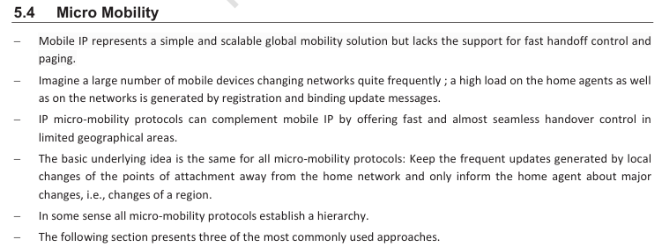

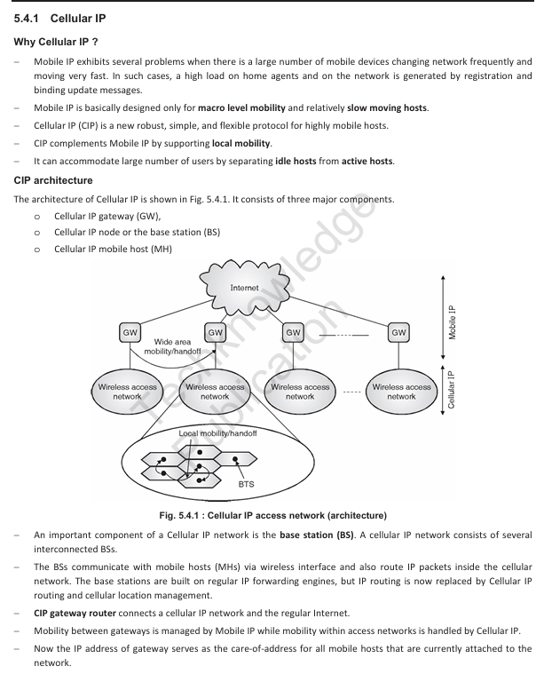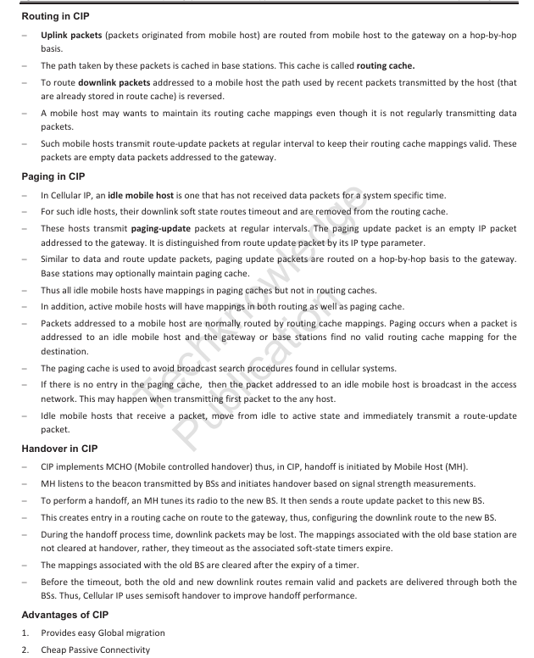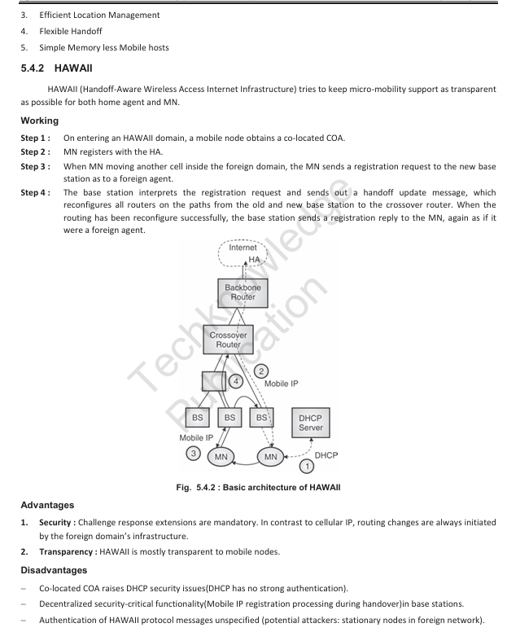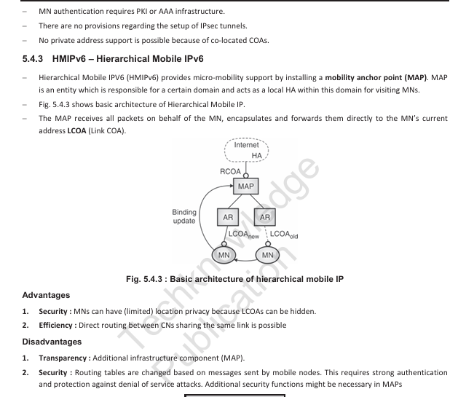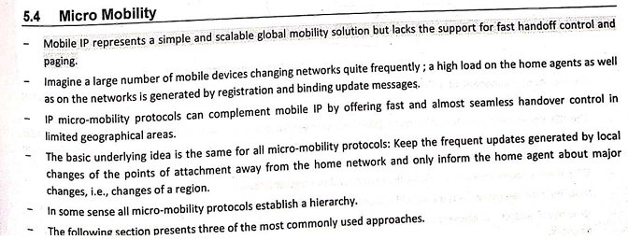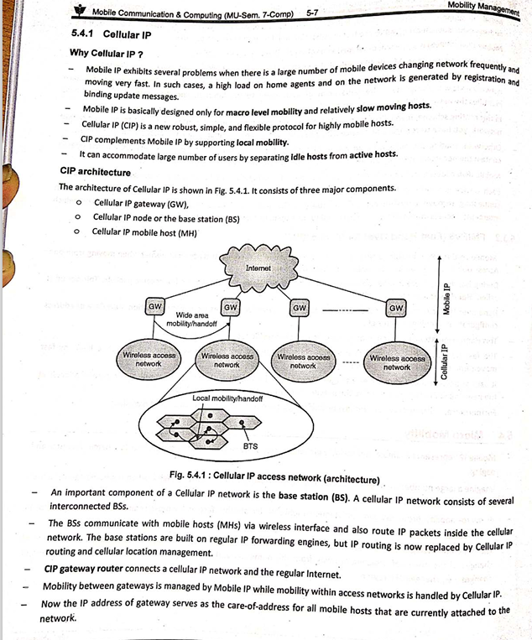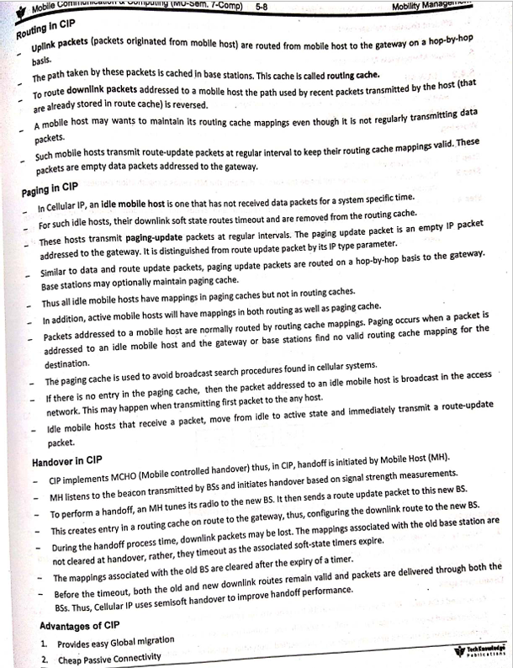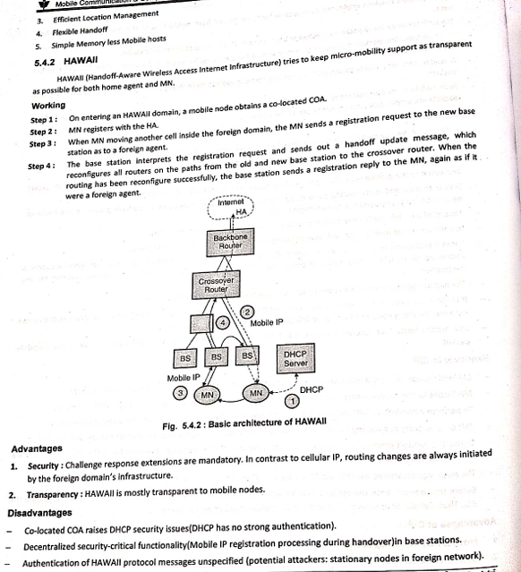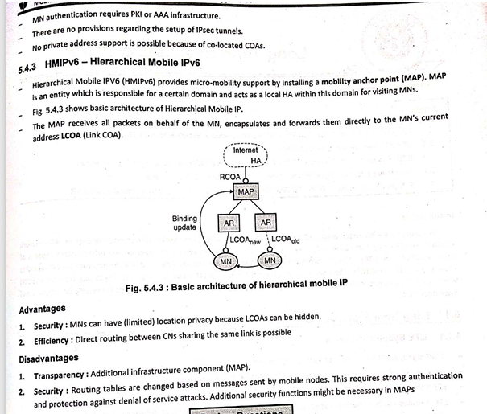

HMIPV6

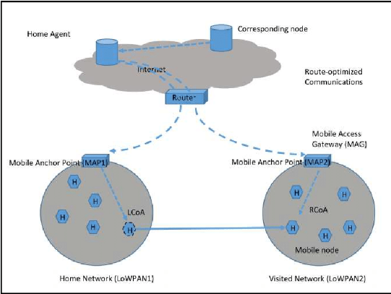

Q. How IP Mobility is achieved in wireless network ||

Q. How IP mobility is achieved in wireless network -10M

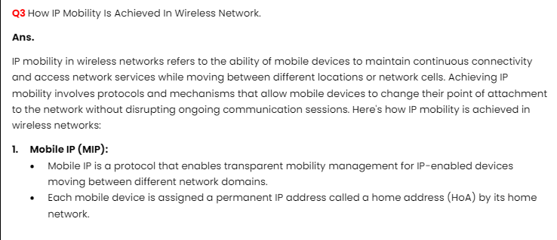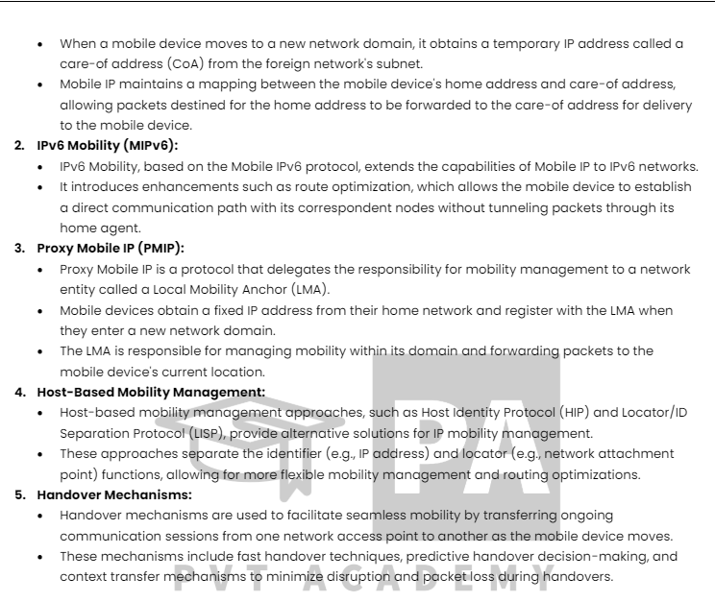

IP mobility in wireless networks is achieved through various protocols and mechanisms that enable mobile devices to maintain connectivity and communication while moving between different network access points or changing their point of attachment to the internet. Here's how IP mobility is achieved:

1. \*\*Mobile IP (MIP)\*\*: Mobile IP is a protocol that enables mobile devices to maintain connectivity and communication as they move across different networks. It works by assigning a unique IP address, known as a Home Address (HA), to the mobile device regardless of its current location. When the device moves to a new network, it obtains a temporary IP address, called a Care-of Address (CoA), from the new network's subnet.

- \*\*Home Agent (HA)\*\*: The Home Agent is a router on the home network responsible for intercepting packets addressed to the mobile device's Home Address and forwarding them to the device's current location (CoA).

- \*\*Foreign Agent (FA)\*\*: In networks where Mobile IP is supported, Foreign Agents assist mobile devices by advertising their presence and providing registration services. When a mobile device moves into a foreign network, it can register with the Foreign Agent to receive packets addressed to its Home Address.

2. \*\*Proxy Mobile IPv6 (PMIPv6)\*\*: Proxy Mobile IPv6 is a network-based mobility management protocol designed to support mobility in IPv6 networks. PMIPv6 simplifies IP mobility by handling mobility management functions within the network infrastructure, eliminating the need for mobile devices to participate actively in mobility management.

- \*\*Mobile Access Gateway (MAG)\*\*: The MAG acts as a mobility anchor point in the network, managing the mobility of mobile nodes within its domain. When a mobile node moves into a new network, it registers with the MAG to obtain a temporary IPv6 address and maintain communication.

- \*\*Local Mobility Anchor (LMA)\*\*: The LMA serves as the home agent for mobile nodes, managing their home addresses and session continuity across different network domains. It maintains the mobility binding information for each mobile node and forwards data packets between the MAG and the mobile node's home network.

3. \*\*Hierarchical Mobile IPv6 (HIPv6)\*\*: Hierarchical Mobile IPv6 is an extension of Mobile IPv6 designed to support hierarchical mobility management in IPv6 networks. HIPv6 organizes mobile nodes into mobility groups, with each group managed by a Mobility Anchor Point (MAP), to improve scalability and reduce signaling overhead.

- \*\*Mobility Anchor Point (MAP)\*\*: The MAP serves as the anchor point for a group of mobile nodes within a localized area. It manages the mobility of mobile nodes within its domain, handles handover events, and maintains session continuity for mobile nodes moving within the group's coverage area.

- \*\*Mobile Router (MR)\*\*: Mobile Routers are mobile nodes that maintain connectivity for one or more attached devices while moving within a MAP's domain. MRs use HIPv6 to register with MAPs and obtain IPv6 addresses for their attached devices, ensuring seamless communication as they move.

These protocols and mechanisms enable mobile devices to maintain connectivity and communication in wireless networks, ensuring seamless mobility and service continuity as users move between different network access points or change their network attachment points.

Q. Short note on : IPV6

IPv6 (Internet Protocol version 6) is the latest version of the Internet Protocol (IP) designed to succeed IPv4. It serves as the foundation for communication and data transmission in modern internet networks. IPv6 was developed to address the limitations of IPv4, primarily the exhaustion of available IPv4 addresses due to the exponential growth of internet-connected devices.

Key features of IPv6 include:

1. \*\*Expanded Address Space\*\*: IPv6 uses a 128-bit address format, providing a significantly larger address space compared to the 32-bit address format used in IPv4. This expansion allows for trillions of unique IP addresses, ensuring an abundant supply of addresses to accommodate the growing number of internet-connected devices.

2. \*\*Efficient Routing and Addressing\*\*: IPv6 incorporates features such as hierarchical addressing and routing, simplifying the routing process and reducing the size of routing tables. It also eliminates the need for network address translation (NAT) used in IPv4, enabling end-to-end connectivity and facilitating peer-to-peer communication.

3. \*\*Improved Security\*\*: IPv6 includes built-in support for IPsec (Internet Protocol Security), a suite of protocols for securing internet communications. IPsec provides authentication, integrity, and confidentiality services for IPv6 traffic, enhancing the overall security of internet communications.

4. \*\*Auto-Configuration\*\*: IPv6 supports stateless address auto-configuration, allowing devices to automatically generate and configure their IPv6 addresses without the need for manual configuration or DHCP (Dynamic Host Configuration Protocol) servers. This simplifies network management and deployment, especially in dynamic network environments.

5. \*\*Mobility Support\*\*: IPv6 includes features to support mobile devices and seamless mobility in IPv6 networks. Protocols such as Mobile IPv6 and Proxy Mobile IPv6 facilitate the mobility of devices by enabling them to maintain connectivity and communication while moving between different network access points.

6. \*\*Transition Mechanisms\*\*: IPv6 incorporates transition mechanisms to facilitate the coexistence and migration from IPv4 to IPv6 networks. These mechanisms include dual-stack operation, tunneling, and translation techniques, allowing IPv6-enabled devices to communicate with IPv4 devices and networks during the transition period.

Overall, IPv6 offers numerous advantages over IPv4, including a larger address space, improved routing efficiency, enhanced security, and support for emerging technologies such as IoT (Internet of Things) and mobile computing. As the adoption of IPv6 continues to grow, it is poised to become the primary protocol for internet communication, ensuring the continued growth and evolution of the global internet infrastructure.

Q. Explain IP mobility

IP mobility, also known as mobile IP, refers to the capability of a mobile device to maintain uninterrupted connectivity and communication while moving between different networks or changing its point of attachment to the internet. In traditional IP networks, devices are assigned IP addresses based on their network attachment point, and changing this point typically results in a loss of connectivity. IP mobility protocols and mechanisms address this limitation by allowing devices to maintain their IP addresses and ongoing communication sessions as they move.

Key components and concepts of IP mobility include:

1. \*\*Home Address (HA)\*\*: Every mobile device is assigned a unique IP address known as its Home Address (HA). The Home Address remains constant regardless of the device's current location or network attachment point. It serves as the device's permanent identifier in the network.

2. \*\*Care-of Address (CoA)\*\*: When a mobile device moves to a new network, it obtains a temporary IP address called a Care-of Address (CoA) from the new network's subnet. The CoA represents the device's current location within the new network and is used to forward data packets to the device while it is away from its home network.

3. \*\*Home Agent (HA)\*\*: The Home Agent is a router located in the mobile device's home network. It maintains a binding between the device's Home Address and its current Care-of Address. Incoming packets addressed to the device's Home Address are intercepted and forwarded by the Home Agent to the device's current Care-of Address.

4. \*\*Foreign Agent (FA)\*\*: In networks where Mobile IP is supported, Foreign Agents assist mobile devices by advertising their presence and providing registration services. When a mobile device moves into a foreign network, it can register with the Foreign Agent to receive packets addressed to its Home Address.

5. \*\*Registration\*\*: When a mobile device moves into a new network, it registers its Care-of Address with its Home Agent or Foreign Agent. Registration involves updating the binding between the device's Home Address and its current Care-of Address, ensuring that incoming packets are forwarded to the device's current location.

6. \*\*Tunneling\*\*: To facilitate communication between the mobile device and its Home Agent, Mobile IP often employs tunneling techniques. Tunneling involves encapsulating IP packets destined for the mobile device's Home Address within IP packets addressed to its Care-of Address, allowing them to traverse the network between the Home Agent and the mobile device.

By utilizing these components and mechanisms, IP mobility protocols such as Mobile IP enable mobile devices to maintain connectivity and communication as they move between different networks or change their network attachment points. This capability is essential for supporting applications and services that require uninterrupted access to network resources, such as mobile internet access, voice over IP (VoIP), and real-time communication applications.

MIPV6

Mobile IPv6 (MIPv6) is a protocol designed to support IP mobility in IPv6 networks. It enables mobile devices to maintain continuous connectivity and communication while moving between different networks or changing their network attachment points. MIPv6 builds upon the principles of Mobile IP (MIP), extending them to the IPv6 protocol suite. Here's a detailed overview of MIPv6:

1. \*\*Basic Concepts\*\*:

- \*\*Home Address (HoA)\*\*: Similar to MIPv4, MIPv6 assigns each mobile device a Home Address (HoA), which serves as its permanent identifier regardless of its current location. The Home Address is associated with the device's home network.

- \*\*Care-of Address (CoA)\*\*: When a mobile device moves to a new network, it obtains a temporary IP address called a Care-of Address (CoA) from the new network's subnet. The CoA represents the device's current location within the new network.

- \*\*Home Agent (HA)\*\*: The Home Agent is a router located in the mobile device's home network. It maintains a binding between the device's Home Address (HoA) and its current Care-of Address (CoA). The Home Agent intercepts and forwards packets addressed to the device's HoA to its CoA.

2. \*\*Protocol Operation\*\*:

- \*\*Registration\*\*: When a mobile device moves into a new network, it initiates a registration process to inform its Home Agent and correspondent nodes (i.e., devices with which it is communicating) of its new Care-of Address. This registration process involves updating the binding between the device's HoA and its CoA.

- \*\*Tunneling\*\*: MIPv6 typically employs tunneling techniques to facilitate communication between the mobile device and its Home Agent. Tunneling involves encapsulating IP packets destined for the mobile device's HoA within IP packets addressed to its CoA, allowing them to traverse the network between the Home Agent and the mobile device.

3. \*\*Route Optimization\*\*:

- \*\*Direct Communication\*\*: In MIPv6, when a correspondent node (CN) wishes to communicate with a mobile device, it can send packets directly to the device's CoA without routing them through the Home Agent. This direct communication between the CN and the mobile device reduces latency and avoids unnecessary tunneling through the home network.

- \*\*Binding Updates\*\*: MIPv6 supports binding updates, allowing mobile devices to inform correspondent nodes of their current CoA without involving the Home Agent. This enables efficient route optimization and reduces the dependency on tunneling for communication.

4. \*\*Security\*\*:

- \*\*IPsec\*\*: MIPv6 leverages IPsec (IP Security) to secure communication between mobile devices, Home Agents, and correspondent nodes. IPsec provides authentication, integrity, and confidentiality services, ensuring the privacy and security of data transmitted over the network.

5. \*\*Enhancements\*\*:

- \*\*Fast Handovers\*\*: MIPv6 supports fast handover mechanisms to minimize handover latency and packet loss during mobility events. Techniques such as Fast Neighbor Discovery (FND) and Fast Binding Update (FBU) help expedite the handover process, enabling seamless connectivity for mobile devices.

- \*\*Hierarchical Mobile IPv6 (HMIPv6)\*\*: MIPv6 can be extended with HMIPv6 to improve scalability and reduce signaling overhead in large-scale IPv6 networks. HMIPv6 introduces a hierarchical mobility management architecture, where mobility management functions are distributed across multiple mobility anchors, enhancing the efficiency of mobility management.

Overall, Mobile IPv6 (MIPv6) provides a robust framework for supporting IP mobility in IPv6 networks, enabling mobile devices to maintain continuous connectivity and communication while moving between different networks or changing their network attachment points.

